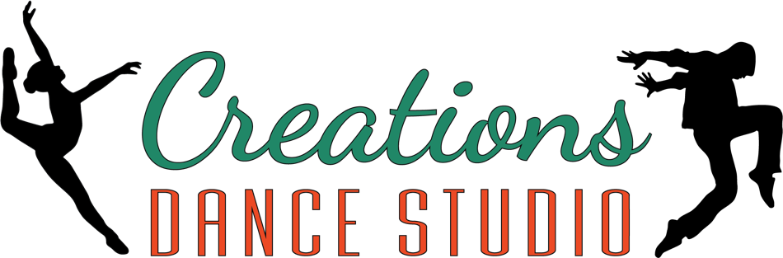
Dance/Tumbling registration form

CLASSES ARE BILLED PER HOUR PER FAMILY. 1/2 AN HOUR: $25, 1 HOURS: $45, 1 1/2 HOURS: $60, 2 HOURS: $70, 2 1/2 HOURS: $75, 3 HOURS: $80, 4 HOURS: $90
UNLIMITED MONTHLY FAMILY CLASSES: 1 STUDENT = $85, 2 STUDENTS = $95, 3 STUDENTS = $105
4 STUDENTS = $115, 5 STUDENTS = $125

Please fill out a separate form for each participating student within your household.
Participation is not allowed without signed registration and consent.

STUDENT NAME: __________________________________________________________________

DATE OF BIRTH: __________________________________ AGE: ____________________

PARENT/GUARDIAN NAME: _________________________________________________________

ADRESS: ________________________________________________________________________

CITY: _____________________________ STATE: ____________ ZIP: ________________

HOME PHONE: ______________________________ CELL: __________________________

EMAIL: ___________________________________________________________________________

WOULD YOU LIKE TO BE ON OUR EMAIL LIST? ___________ TEXT LIST? ___________

EMERGENCY CONTACT: ____________________________________________________________

CLASS 1: __________________________________ DAY TIME:_____________________________
CLASS 1: __________________________________ DAY TIME:_____________________________
CLASS 1: __________________________________ DAY TIME:_____________________________
CLASS 1: __________________________________ DAY TIME:_____________________________
CLASS 1: __________________________________ DAY TIME:_____________________________
CLASS 1: __________________________________ DAY TIME:_____________________________
AMOUNT DUE: ______________ AMOUNT PAID: ______________ EMP. INITIALS _____________

WAIVER: PARTICIPANT IN ANY AND ALL OF CREATIONS DANCE STUDIO’S ACTIVITIES ARE NOT COVERED BY MEDICAL OR ACCIDENTAL INSURANCE. EACH PARTICIPANT MUST FURNISH HIS OR HER OWN PERSONAL COVERAGE. DANCE AND TUMBLING ACTIVITES HAVE INHERENT ELEMENTS OF DANGER. PARTICIPANT OR PARENT PERMISSION IS NEEDED IN ORDER TO CALL AN AMBULANCE IN AN EMERGENCY SITUATION. AS A PARTICIPANT, OR PARENT/GUARDIAN OF A MINOR PARTICIPANT, I HEREBY TO SAVE HARMLESS AND INDEMNIFY CREATIONS DANCE STUDIO, IT’S TRUSTEES AND EMPLOYEES FROM ANY RESPONSIBILITY FOR ANY ACCIDENT, INJURY, OR DAMAGE THAT MAY OCCUR AS A RESULT OF THE PARTICIPANTS ACTS OR OMISSIONS. IN CASE OF ACCIDENT OR SICKNESS, I CONSENT TO EMERGENCY MEDICAL CARE BY AMBULANCE OR HOSPITAL PERSONNEL.

PARENT/GUARDIAN SIGNATURE: __________________________________ DATE: ___________

